Summer 2022

MBA 562

Introduction to Business Analytics:

Communicating with Data

Module 2 Individual Assignment:

Bryan Yang

Bryany4@illinois.edu

Table of Contents

Step 1 & 2:  3

References: 4

# Step 1 & 2:

Your first step will be to create a plan for a data story by submitting a report that features a structurally sound pyramid (i.e., adheres to the Minto Pyramid Principle rules discussed in the module).

After drawing a pyramid structure and Situation, Complication, Question (SCQ) introduction lines, create a plan for your analysis by filling in the boxes of your pyramid structure. Your plan should include a hypothesis, at least three key questions for analysis, and at least three pieces of data and sources for those data for each key question. Your plan will be constructed most efficiently using the Minto “Top-Down” approach and incorporating clues provided in the case study (i.e., What is Lindsay Silk-

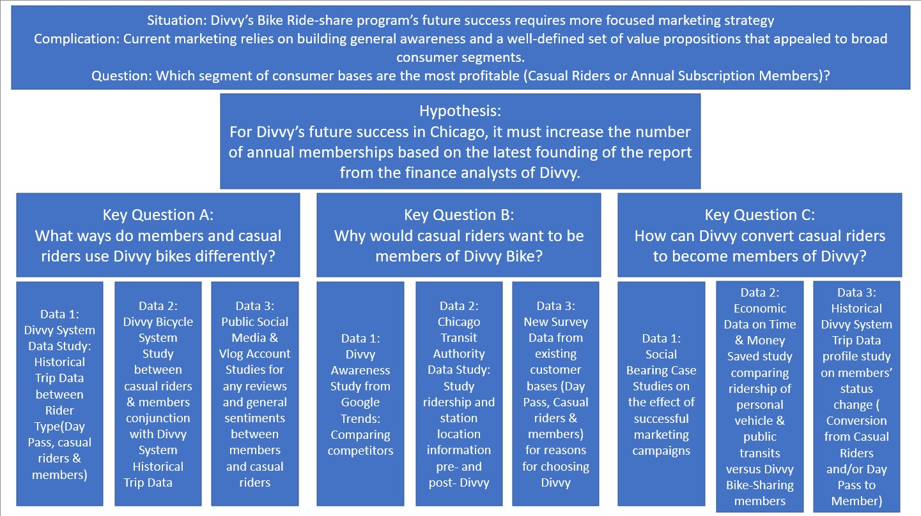

# References:

Hartman, K, (2022, May), Introduction to Business Analytics: Communicating with Data

MBA 562 Module 1-2

Hartman, K. (2022, May). *‘Sophisticated, Clear, and Polished’: Divvy and Data Visualization (Case Study)*. Art + Science: A DATA (AND OTHER THINGS) BLOG. Retrieved May 2022, Retrieved from

<https://artscience.blog/home/divvy-dataviz-case-studyhttps://artscience.blog/home/divvy-dataviz-case-study>